MULTICULTURAL FLAG ART

Ask your parents which country’s flag they feel best represents their heritage. Draw/Colour that countries flag below.

1) Mom’s Flag 2) My Flag 3) Dad’s Flag
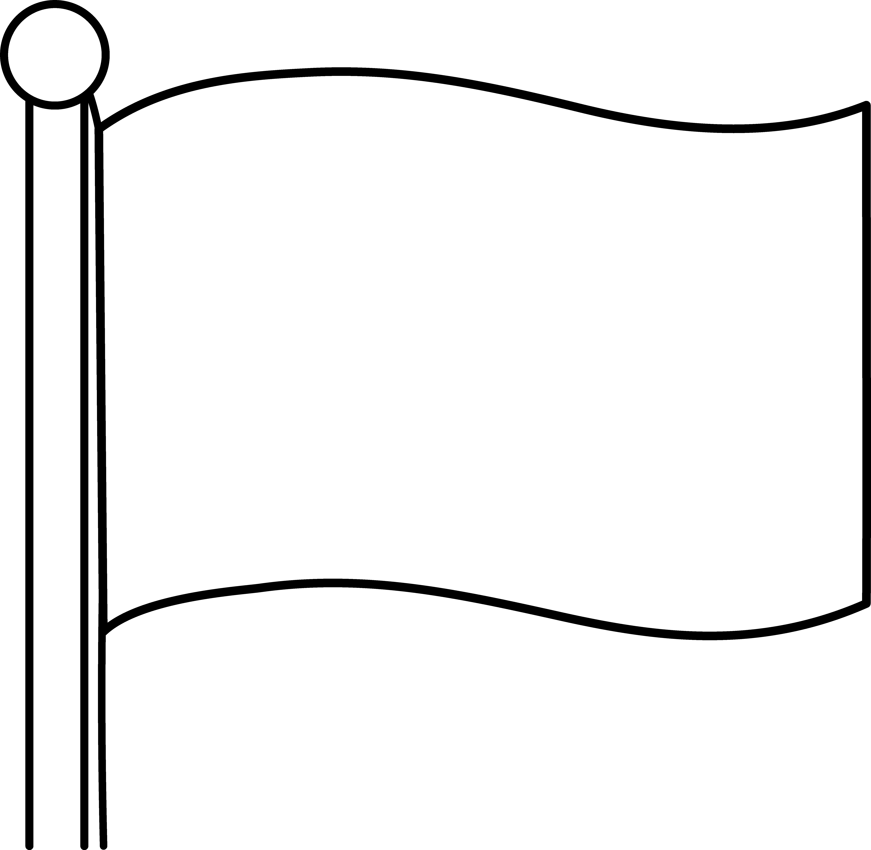

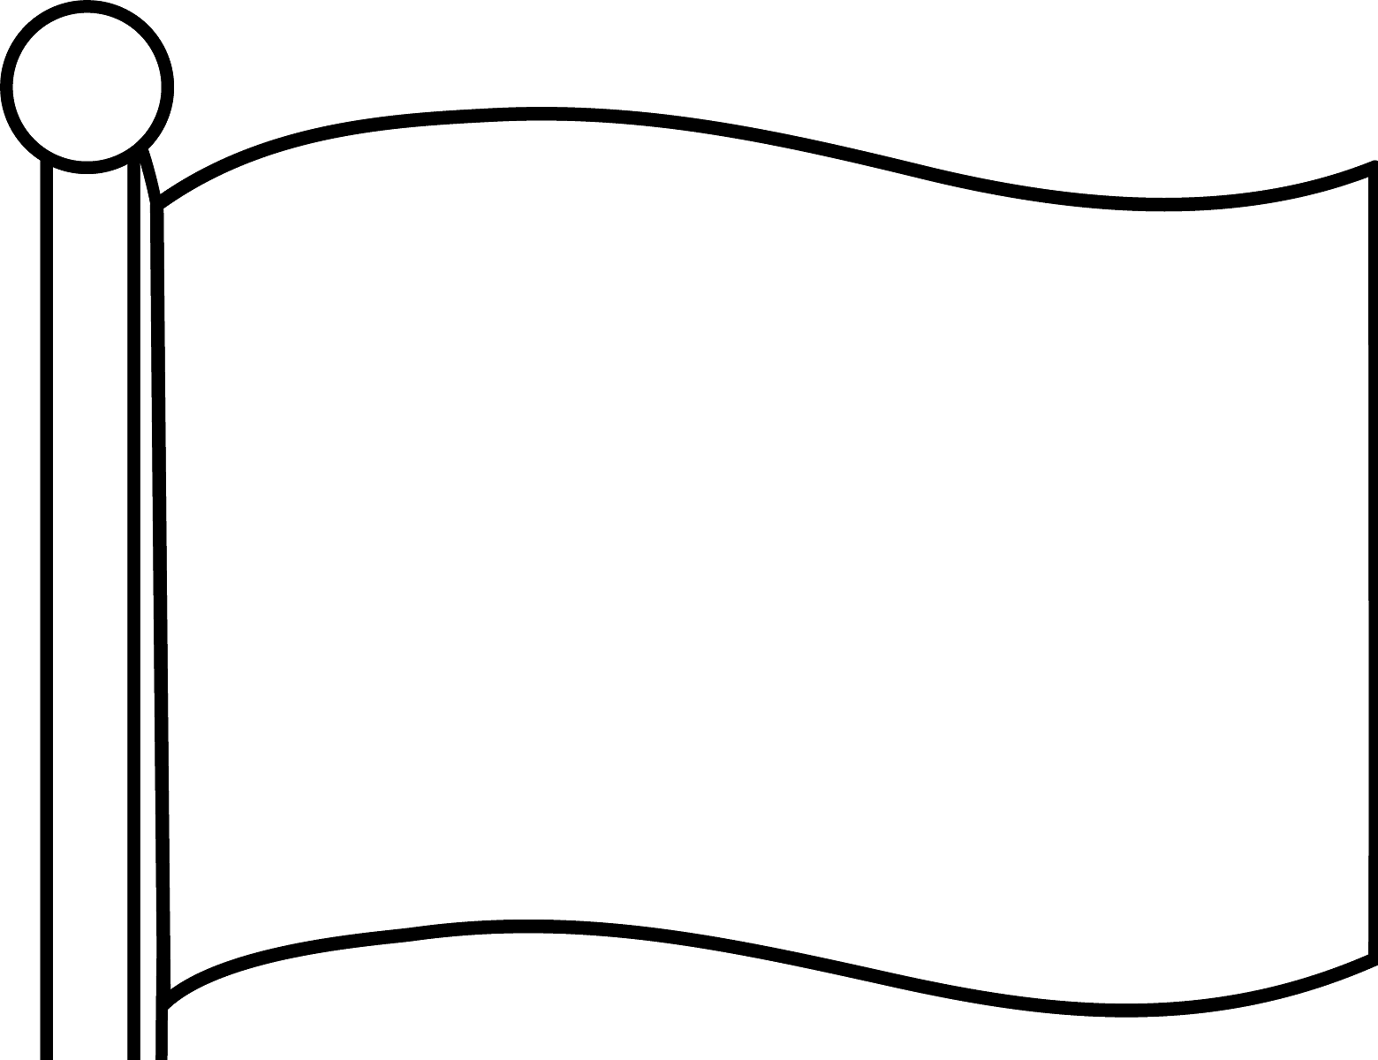
I know the Maple Leaf on the Canadian flag can be difficult to draw so you can colour and cut out the ones below if needed.

4) My Creation

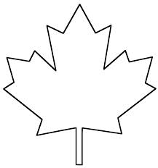
For this flag, I would like you to creatively combine the flags 1, 2 & 3 to create a new multicultural Canadian flag that you feel best represents you and your family.

